Memory management
Memory management is the functionality of an operating system which handles or manages primary memory and moves processes back and forth between main memory and disk during execution. Memory management keeps track of each and every memory location, regardless of either it is allocated to some process or it is free. It checks how much memory is to be allocated to processes. It decides which process will get memory at what time. It tracks whenever some memory gets freed or unallocated and correspondingly it updates the status.

Logical Versus Physical Address Space
An address generated by the CPU is commonly referred to as a logical address, whereas an address seen by the memory unit—that is, the one loaded into the memory-address register of the memory—is commonly referred to as a physical address.
The compile-time and load-time address-binding methods generate identical logical and physical addresses. However, the execution-time address binding scheme results in differing logical and physical addresses. In this case, we usually refer to the logical address as a virtual address. We use logical address and virtual address interchangeably in this text. The set of all logical addresses generated by a program is a logical address space; the set of all physical addresses corresponding to these logical addresses is a physical address space. Thus, in the execution-time address-binding scheme, the logical and physical address spaces differ. The run-time mapping from virtual to physical addresses is done by a hardware device called the memory-management unit (MMU).
+
CPU
Relocation register

14000

MEMORY

logical Address physical address
346 14346

MMU

we illustrate this mapping with a simple MMU scheme, which is a generalization of the base-register scheme. The base register is now called a relocation register. The value in the relocation register is added to every address generated by a user process at the time it is sent to memory For example, if the base is at 14000, then an attempt by the user to address location 0 is dynamically relocated to location 14000; an access to location 346 is mapped to location 14346.

Swapping
A process must be in memory to be executed. A process, however, can be swapped temporarily out of memory to a backing store and then brought back into memory for continued execution. For example, assume a multiprogramming environment with a round-robin CPU-scheduling algorithm. When a quantum expires, the memory manager will start to swap out the process that just finished and to swap another process into the memory space that has been freed. In the meantime, the CPU scheduler will allocate a time slice to some other process in memory. When each process finishes its quantum, it will be swapped with another process. Ideally, the memory manager can swap processes fast enough that some processes will be in memory, ready to execute, when the CPU scheduler wants to reschedule the CPU. In addition, the quantum must be large enough to allow reasonable amounts of computing to be done between swaps.
A variant of this swapping policy is used for priority-based scheduling algorithms. If a higher-priority process arrives and wants service, the memory manager can swap out the lower-priority process and then load and execute the higher-priority process. When the higher-priority process finishes, the lower-priority process can be swapped back in and continued. This variant of swapping is sometimes called roll out, roll in.
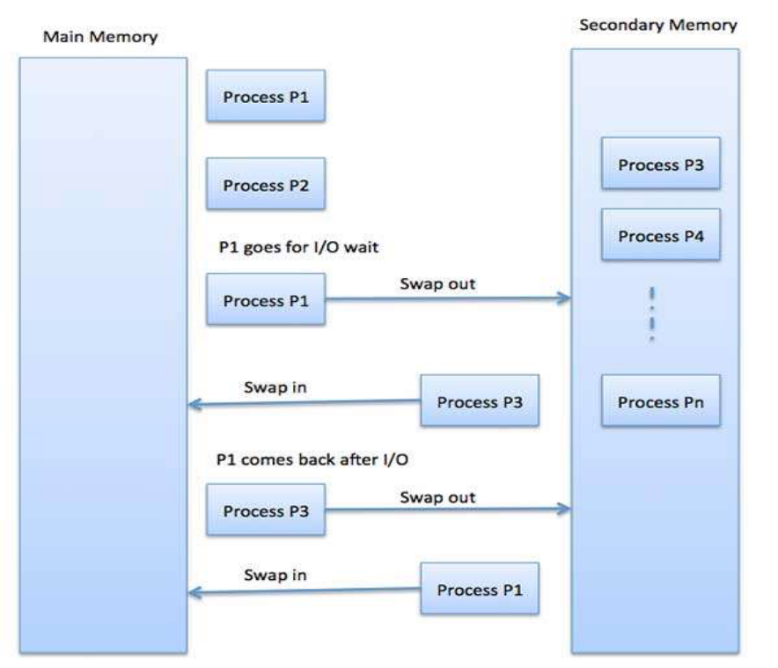
Swapping requires a backing store. The backing store is commonly a fast disk. It must be large enough to accommodate copies of all memory images for all users, and it must provide direct access to these memory images. The system maintains a ready queue consisting of all processes whose memory images are on the backing store or in memory and are ready to run. Wlie never the CPU scheduler decides to execute a process, it calls the dispatcher. The dispatcher checks to see whether the next process in the queue is in memory. If it is not, and if there is no free memory region, the dispatcher swaps out a process currently in memory and swaps in the desired process. It then reloads registers and transfers control to the selected process.

Swapping is constrained by other factors as well. If we want to swap a process, we must be sure that it is completely idle. Of particular concern is any pending I/O. A process may be waiting for an I/O operation when we want to swap that process to free up memory. However, if the I/O is asynchronously accessing the user memory for I/O buffers, then the process cannot be swapped. Assume that the I/O operation is queued because the device is busy. If we were to swap out process Pi and swap in process Po, the I/O operation might then attempt to use memory that now belongs to process Pi. There are two main solutions to this problem: Never swap a process with pending I/O, or execute I/O operations only into operating-system buffers. Transfers between operating-system buffers and process memory then occur only when the process is swapped in.

Contiguous Memory Allocation
The main memory must accommodate both the operating system and the various user processes. We usually want several user processes to reside in memory at the same time. We therefore need to consider how to allocate available memory to the processes that are in the input queue waiting to be brought into memory. In this contiguous memory allocation, each process is contained in a single contiguous section of memory.
- Memory Mapping and Protection
We can provide these features by using a relocation register, with a limit register. The relocation register contains the value of the smallest physical address; the limit register contains the range of logical addresses (for example, relocation = 100040 and limit = 74600). With relocation and limit registers, each logical address must be less than the limit register; the MMU maps the logical address dynamically by adding the value in the relocation register. This mapped address is sent to memory.
When the CPU scheduler selects a process for execution, the dispatcher loads the relocation and limit registers with the correct values as part of the context switch. Because every address generated by the CPU is checked against these registers, we can protect both the operating system and the other users programs and data from being modified by this running process.
<
+
CPU

MEMORY
limit register
Base register

logical address YES physical address

NO

trap

- Memory Allocation
One of the simplest methods for allocating memory is to divide memory into several fixed-sized partitions. Each partition may contain exactly one process. when a partition is free, a process is selected from the input queue and is loaded into the free partition. When the process terminates, the partition becomes available for another process.

In the fixed-partition scheme, the operating system keeps a table indicating which parts of memory are available and which are occupied. Initially, all memory is available for user processes and is considered one large block of available memory, a hole. When a process arrives and needs memory, we search for a hole large enough for this process. If we find one, we allocate only as much memory as is needed, keeping the rest available to satisfy future requests.

As processes enter the system, they are put into an input queue. The operating system takes into account the memory requirements of each process and the amount of available memory space in determining which processes are allocated memory. When a process is allocated space, it is loaded into memory, and it can then compete for the CPU. When a process terminates, it releases its memory, which the operating system may then fill with another process from the input queue.

At any given time, we have a list of available block sizes and the input queue. The operating system can order the input queue according to a scheduling algorithm. Memory is allocated to processes until, finally, the memory requirements of the next process cannot be satisfied—that is, no available block of memory (or hole) is large enough to hold that process. The operating system can then wait until a large enough block is available, or it can skip down the input queue to see whether the smaller memory requirements of some other process can be met.

we have a set of holes of various sizes scattered throughout memory. When a process arrives and needs memory, the system searches the set for a hole that is large enough for this process. If the hole is too large, it is split into two parts. One part is allocated to the arriving process; the other is returned to the set of holes. When a process terminates, it releases its block of memory, which is then placed back in the set of holes. If the new hole is adjacent to other holes, these adjacent holes are merged to form one large hole. At this point, the system may need to check whether there are processes waiting for memory and whether this newly freed and recombined memory could satisfy the demands of any of these waiting processes.

This procedure is a particular instance of the general dynamic storage allocation problem, which concerns how to satisfy a request of size n from a list of free holes. There are many solutions to this problem. The first-fit, best-fit, and worst-fit strategies are the ones most commonly used to select a free hole from the set of available holes.

- First fit. Allocate the first hole that is big enough. Searching can start either at the beginning of the set of holes or where the previous first-fit search ended. We can stop searching as soon as we find a free hole that is large enough.

- Best fit. Allocate the smallest hole that is big enough. We must search the entire list, unless the list is ordered by size. This strategy produces the smallest leftover hole.

- Worst fit. Allocate the largest hole. Again, we must search the entire list, unless it is sorted by size. This strategy produces the largest leftover hole, which may be more useful than the smaller leftover hole from a best-fit approach.

- Fragmentation
As processes are loaded and removed from memory, the free memory space is broken into little pieces. It happens after sometimes that processes cannot be allocated to memory blocks considering their small size and memory blocks remains unused. This problem is known as Fragmentation.
Fragmentation is of two types −
- External fragmentation
Total memory space is enough to satisfy a request or to reside a process in it, but it is not
contiguous, so it cannot be used.
- Internal fragmentation
Memory block assigned to process is bigger. Some portion of memory is left unused, as
it cannot be used by another process.

One solution to the problem of external fragmentation is compaction. The goal is to shuffle the memory contents so as to place all free memory together in one large block.
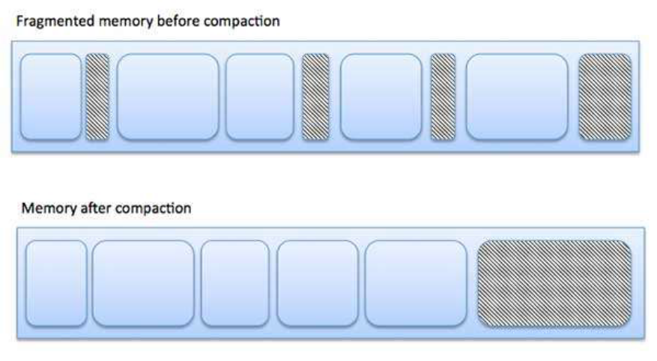
The internal fragmentation can be reduced by effectively assigning the smallest partition but large enough for the process.

Paging

Paging is a memory-management scheme that permits the physical address space a process to be non-contiguous. Paging avoids external fragmentation and the need for compaction. It also solves the considerable problem of fitting memory chunks of varying sizes onto the backing store.
Basic Method:
The basic method for implementing paging involves breaking physical memory into fixed-sized blocks called frames and breaking logical memory into blocks of the same size called pages.When a process is to be executed, its pages are loaded into any available memory frames from their source (a file system or the backing store). The backing store is divided into fixed-sized blocks that are of the same size as the memory frames.
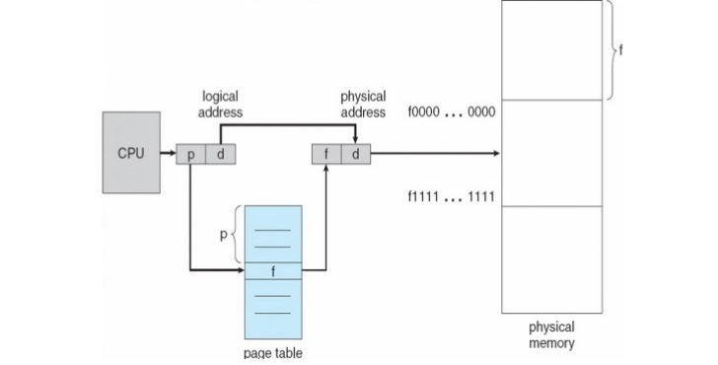
Paging hardware
Every address generated by the CPU is divided into two parts: a page number{p) and a page offset(d). The page number is used as an index into a page table.The page table contains the base address of each page in physical memory. This base address is combined with the page offset to define the physical memory address that is sent to the memory unit..
The size of a page is typically a power of 2, varying between 512 bytes and 16 MB per page, depending on the computer architecture.
If the size of the logical address space is 2^m, and a page size is 2^n addressing units (bytes or words) then the high-order m- n bits of a logical address designate the page number, and the n low-order bits designate the page offset. Thus, the logical address is a

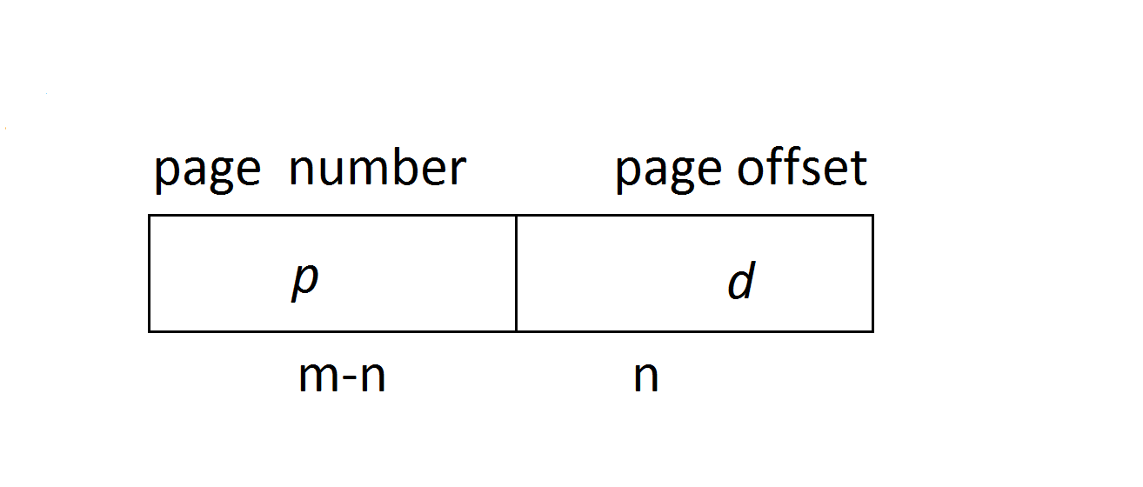
where p is an index into the page table and d is the displacement within the page.
Example:
Using a page size of 4 bytes and a physical memory of 32 bytes (8 pages), we show how the
user's view of memory can be mapped into physical memory.

Physical address = [(frame no. x page size) + offset]
Logical address 0 is page 0, offset 0. Indexing into the page table, we find that page 0 is in frame 5.
Thus, logical address 0 maps to physical address 20 = [ (5 x 4) + 0].

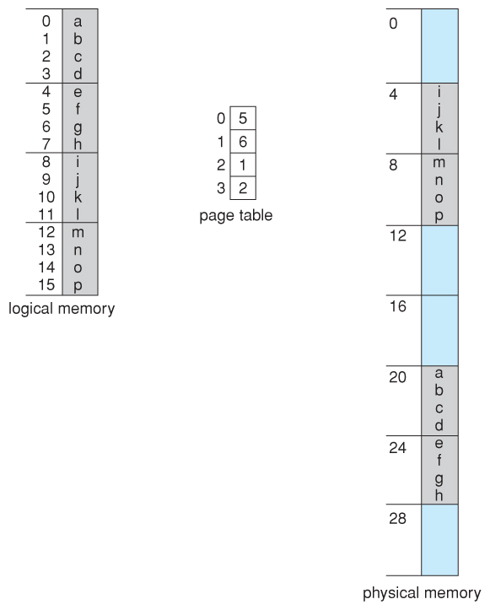
Paging example for a 32-byte memory with 4-byte page
Hardware Support

OS use a special, small, fastlookup hardware cache, called a translation look-aside buffer(TLB).The TLB is associative, high-speed memory. Each entry in the TLB consists of two parts: a key (or tag) and a value. When the associative memory is presented with an item, the item is compared with all keys simultaneously. If the item is found, the corresponding value field is returned. The search is fast; the hardware, however, is expensive. Typically, the number of entries in a TLB is small, often numbering between 64 and 1,024. The TLB is used with page tables in the following way. The TLB contains only a few of the page-table entries. When a logical address is generated by the CPU, its page number is presented to the TLB. If the page number is found, its frame number is immediately available and is used to access memory. The whole task may take less than 10 percent longer than it would if an unmapped
memory reference were used.
If the page number is not in the TLB (known as a TLB miss),a memory reference to the page table must be made. When the frame number is obtained, we can use it to access memory . In addition, we add the page number and frame number to the TLB, so that they will be found quickly on the next reference. If the TLB is already full of entries, the operating system must
select one for replacement. Replacement policies range from least recently used (LRU) to random. Furthermore, some TLBs allow certain entries to be wired down, meaning that they cannot be removed from the TLB. Typically, TLB entries for kernel code are wired down
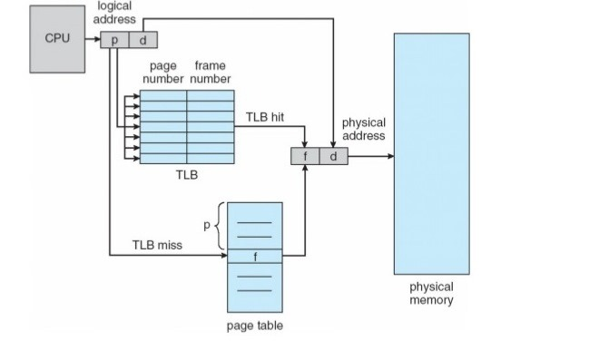

Protection
Memory protection in a paged environment is accomplished by protection bits associated with each frame. Normally, these bits are kept in the page table. One additional bit is generally attached to each entry in the page table: a valid-invalid bit. When this bit is set to "valid," the associated page is in the process's logical address space and is thus a legal (or valid) page. When the bit is set to"invalid," the page is not in the process's logical address space. Illegal addresses are trapped by use of the valid -invalid bit. The operating system sets this bit for each page to allow or disallow access to the page.
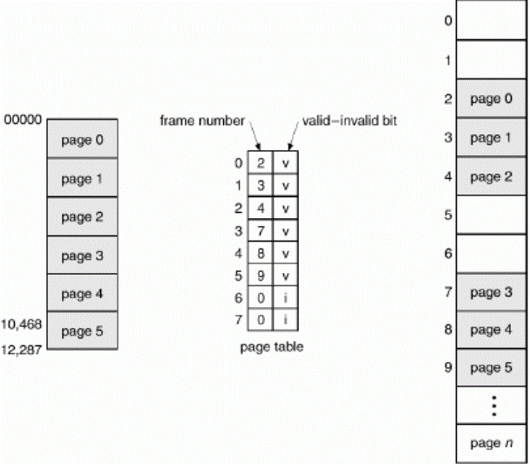
Addresses pages 0, 1, 2, 3, 4, and 5 are mapped normally through the page table. Any attempt to generate an address in pages 6 or 7, however, will find that the valid -invalid bit is set to invalid, and the computer will trap to flee operating system (invalid page reference).

Structure of the Page Table
Some of the most common techniques for structuring the page table are given below:
- Hierarchical Paging
- Hashed Page Table
- Inverted Page Table
Hierarchical Paging:-

Most modern computer systems support a large logical address space(2³² to 2⁶⁴). In such an environment, the page table itself becomes excessively large. For example, consider a system with a 32-bit logical address space. If the page size in such a system is 4KB(2¹²),then a page table may consist of upto 1 million entries(2³² /2¹² ). One simple solution to this problem is to divide the page table into smaller pieces.
One way is to use a two-level paging algorithm, in which the page table itself is also paged.

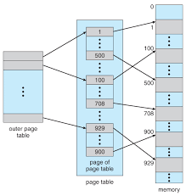
For example, consider again the system witha 32-bit logical address space and a page size of 4 KB. A logical address is divided into a page number consisting of 20 bits and a page offset consisting of 12 bits. Because we page the page table, the page number is further divided into a 10-bit page number and a 10-bit page offset.

Page number Page offset
P2
d
P1
10 10 12
where p1 is an index into the outer page table and p2 is the displacement within the page of the outer page table.

Suppose that the outer page table is made up of standard size pages(2¹⁰ entries, or 2¹²bytes).In this case, a 64-bit address space is still daunting .The outer page table is still 2³⁴ bytes in size.
The next step would be a four level paging scheme, where the second level outer page table itself is also paged, and so forth.The 64-bit UltraSPARC would require seven levels of paging-a prohibitive number of memory accessesto translate each logical address. You can see from this example why, for 64-bit architectures, hierarchical page tables are generally considered inappropriate

Hashed Page Tables:-

A common approach for handling address spaces larger than 32 bits is to use a hashed page table, with the hash value being the virtual page number. Each element consists of three fields: 1. the virtual page number, 2. the value of the mapped page frame, and 3. a pointer to the next element in the linked list.

The algorithm works as follows: The virtual page number in the virtual address is hashed into the hash table. The virtual page number is compared with field 1 in the first element in the linked list. If there is a match, the corresponding page frame (field 2) is used to form the desired physical address. If there is no match, subsequent entries in the linked list are searched for a matching virtual page number. This scheme is shown in the figure.

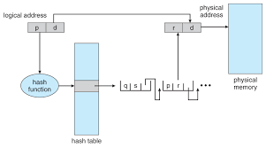

Inverted Page Table:-
Usually, each process has an associated page table. The page table has one entry for each page that the process is using. One of the drawbacks of this method is that each page table may consist of millions of entries. These tables may consume large amounts of physical memory just to keep track of how other physical memory is being used.
To solve this problem, we can use an inverted page table. An inverted page table has one entry for each real page of memory. Each entry consists of the virtual address of the page stored in that real memory location, with information about the process that owns the page. Thus, only one page table is in the system, and it has only one entry for each page of physical memory. The figure is shown

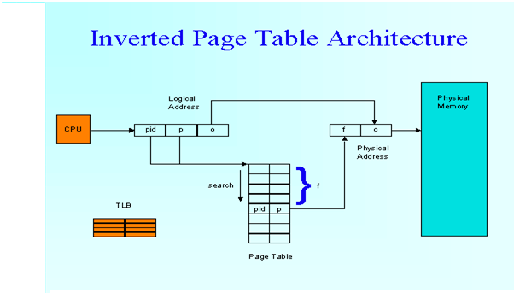

Storing the address space identifier ensures that a logical page for a particular process is mapped to the corresponding physical page frame. Example of system using inverted page table include the 64bit Ultra SPARC and PowerPC.

Each virtual address in the system consists of a triple:

Process id | Page number | offset

Process id assumes the role of the address space identifier. When a memoryreference occurs, part of the virtual address, consisting of <process-id, pagenumber>, is presented to the memory subsystem. The inverted page table is then searched for a match. If a match is found-say, at entry i-then the physical address <i, offset> is generated. If no match is found, then an illegal address access has been attempted. Although this scheme decreases the amount of memory needed to store each page table, it increases the amount of time needed to search the table when a page reference occurs. Because the inverted page table is sorted by physical address, but lookups occur on virtual addresses, the whole table might need to be searched for a match. This search would take far too long. To alleviate this problem, we use a hash table.
Systems that use inverted page tables have difficulty implementing shared memory. Shared memory is usually implemented as multiple virtual address that are mapped to one physical address.

Shared pages:-

An advantage of paging is the responsibility of sharing common code. This consideration is particularly important in time sharing environment. The sharing of memory among process on a system is similar to the sharing of the address space of a task by threads. We described shared memory as a method of interprocess communication. Some operating systems implement shared memory using shared pages. Organizing memory according to pages provides numerous benefits in addition to allowing several process to share the same physical pages.

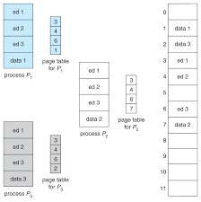

Other heavily used programs can be shared-compilers ,window systems , runtime libraries, database systems, and so on. To be shareable, the code must be reentrant. The read-only nature of shared code should not be left to the correctness of the code; the operating system should enforce this property.
Segmentation
An important aspect of memory management that became unavoidable with paging is the separation of the user's view of memory and the actual physical memory. As we have already seen, the user's view of memory is not the same as the actual physical memory. The user's view is mapped onto physical memory. This mapping allows differentiation between logical memory and. physical memory.

Basic Method
Segmentation is a memory-management scheme that supports this user view of memory. A logical address space is a collection of segments. Each segment has a name and a length. The addresses specify both the segment name and the offset within the segment. The user therefore specifies each address by two quantities: a segment name and an offset. (Contrast this scheme with the paging scheme, in which the user specifies only a single address, which is partitioned by the hardware into a page number and an offset, all invisible to the programmer.) For simplicity of implementation, segments are numbered and are referred to by a segment number, rather than by a segment name. Tluis, a logical address consists of a two tuple:
< segment-number, offset >.
Normally, the user program is compiled, and the compiler automatically constructs segments reflecting the input program. A C compiler might create separate segments for the following:
1. The code
2. Global variables
3. The heap, from which memory is allocated
4. The stacks used, by each thread
5. The standard C library
Libraries that are linked in during compile time might be assigned separate segments. The loader would take all these segments and assign them segment numbers.
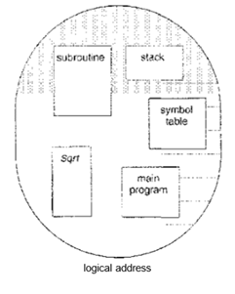

Hardware
Although the user can now refer to objects in the program by a two-dimensional address, the actual physical memory is still, of course, a one-dimensional sequence of bytes. Thus, we must define an implementation to map two dimensional user-defined addresses into one-dimensional physical addresses.
A logical address consists of two parts: a segment number, s, and an offset into that segment, d. The segment number is used as an index to the segment table. The offset d of the logical address must be between 0 and the segment limit. If it is not, we trap to the operating system (logical addressing attempt beyond, end of segment). When an offset is legal, it is added to the segment base to produce the address in physical memory of the desired byte. The segment table is thus essentially an array of base-limit register pairs.

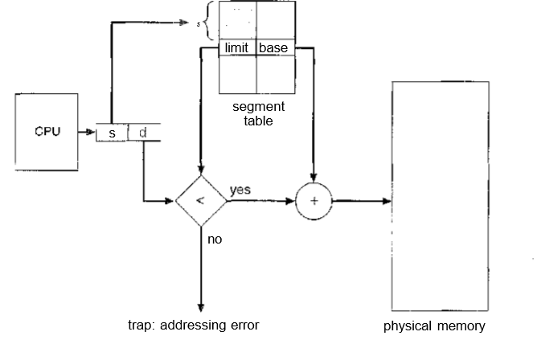

We have five segments numbered from 0 through 4. The segments are stored in physical memory as shown. The segment table has a separate entry for each segment, giving the beginning address of the segment in physical memory (or base) and the length of that segment (or limit). For example, segment 2 is 400 bytes long and begins at location 4300. Thus, a reference to byte 53 of segment 2 is mapped onto location 4300 + 53 = 4353. A reference to segment 3r byte 852, is mapped to 3200 (the base of segment 3) + 852 = 4052. A reference to byte 1222 of segment 0 would result in a trap to the operating system, as this segment is only 1,000 bytes long.

